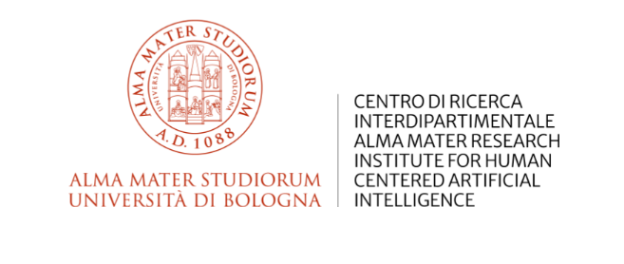

Final Conference | ERC CompuLaw
14-15 July, 2025 – Sala del Consiglio, Villa Salviati
European University Institute

Day 1: 14 July (9:00 – 19:00)

9:00-9:10 Welcome by Prof. Giovanni Sartor (University of Bologna & European University Institute)

9:10-9:50 Keynote Speaker: Prof. Roger Brownsword (King's College London)

Session I: AI and the Rule of Law (9:50 – 13:00)

Introduction to the Panel: Prof. Giovanni Sartor (University of Bologna & European University Institute)
Moderator: Prof. Juliano Maranhao (University of São Paulo)

9:50-10:15 | Prof. Hans-Wolfgang Micklitz (European University Institute)
10:15-10:40 | Prof. Giuseppe Contissa (University of Bologna), Federico Galli (University of Bologna)
10:40-11:00 | Prof. Amedeo Santosuosso (University School for Advanced Studies IUSS Pavia)
11:00-11:30 | Coffee Break
11:30-11:50 | Przemysław Pałka (Jagiellonian University in Krakow)
11:50-12:10 | Prof. Pompeu Casanovas (Artificial Intelligence Research Institute of the Spanish National Research Council)
12:10-12:30 | Prof. Ilaria Caggiano (Università degli Studi Suor Orsola Benincasa)
12:30-13:00 | Discussion

13:00-14:00 Lunch Break

14:00-14:40 Keynote Speaker: Prof. Henry Prakken (Utrecht University)

Session II: Symbolic Methods (14:40 – 19:00)
Introduction to the Panel: Prof. Giovanni Sartor (University of Bologna & European University Institute)
Moderator: Prof. Adam Wyner (Swansea University)

14:40-15:05 | Prof. Juliano Maranhao (University of São Paulo)
15:05-15:30 | Prof. Emiliano Lorini (IRIT: Institut de Recherche en Informatique de Toulouse), Rūta Liepiņa (University of Bologna)
15:30-16:00 | Giuseppe Pisano (University of Bologna), Prof. Roberta Calegari (University of Bologna)
16:00-16:30 | Coffee break
16:30-16:55 | Alessandro Parenti (University of Bologna), Prof. Cosimo Laneve (University of Bologna)
16:55-17:15 | Prof. Floris Bex (Utrecht University)
17:15-17:35 | Prof. A. Ciabattoni (TU Wien Informatics)
17:35-17:55 | Prof. Andrea Omicini (University of Bologna),
17:55-18:20 | Prof. Guido Governatori (Central Queenssland University)
18:20-18:50 | Discussion
From 19:00 Reception and Social Dinner at Villa Salviati

Day 2: 15 July (9:00 – 13:00)

9:00-09:30 Keynote Speaker: Prof. Kevin D. Ashley (University of Pittsburgh)

09:30-13:00 Session III: Sub-Symbolic/Hybrid Methods
Introduction to the Panel: Prof. Giovanni Sartor (University of Bologna & European University Institute)
Moderator: Prof. Riccardo Rovatti (University of Bologna)

9:30-9:55 | Prof. Francesca Lagioia (University of Bologna & European University Institute)
9:55-10:20 | Marco Billi (University of Bologna)
10:20-10:40 | Prof. Andrea Loreggia (University of Brescia)
11:40-11:00 | Galileo Sartor (Swansea University), Thiago Raulino Dal Pont (University of Bologna)
11:00-11:30 | Coffee Break
11:30-11:50 | Prof. Monica Palmirani (University of Bologna)
11:50-12:10 | Prof. Arthur Dyevre (Catholic University of Leuven)
12:10-12:30 | Prof. Marco Lippi (University of Florence)
12:30-12:50 | Discussion

12:50 – 13:00 Conclusions, Prof. Giovanni Sartor (University of Bologna & European University Institute)

Lunch

Organizing and Scientific Committee:

Prof. Giovanni Sartor (University of Bologna)
Federico Galli (University of Bologna)
Paola Aurucci (European University Institute)

For further information please contact: paola.aurucci@unibo.it and arianna.morel@eui.eu

This event is part of the Computable Law project (“CompuLaw”) funded by European Research Council (ERC) - Grant Agreement no. 833647.

